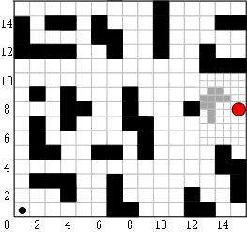

**Fig 1. SAR robot movement space.**